Project Report

India’s Agricultural Crop Production Analysis (1997-2021)

1. INTRODUCTION

1.1 Overview

India’s agricultural is composed of many crops, with the foremost food staples being rice and wheat.

1.2 Purpose

* Agriculture is the foundation of the Indian economy.
* It plays a vital role in the economic growth of the country by contributing to around 14 to 15% of the Gross Domestic Product.
* India has a strong backbone in the Indian economy due to the significant contribution made by the farmers.

2. PROBLEM DEFINITION AND DESIGN THINKING

2.1 Empathy 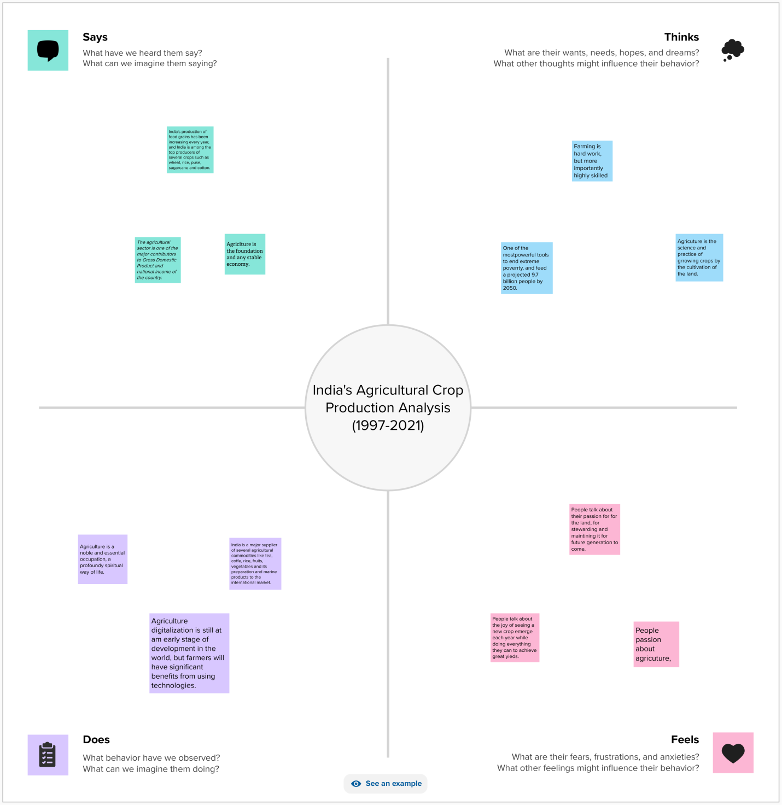

2.2 Ideation and Brainstorming Map

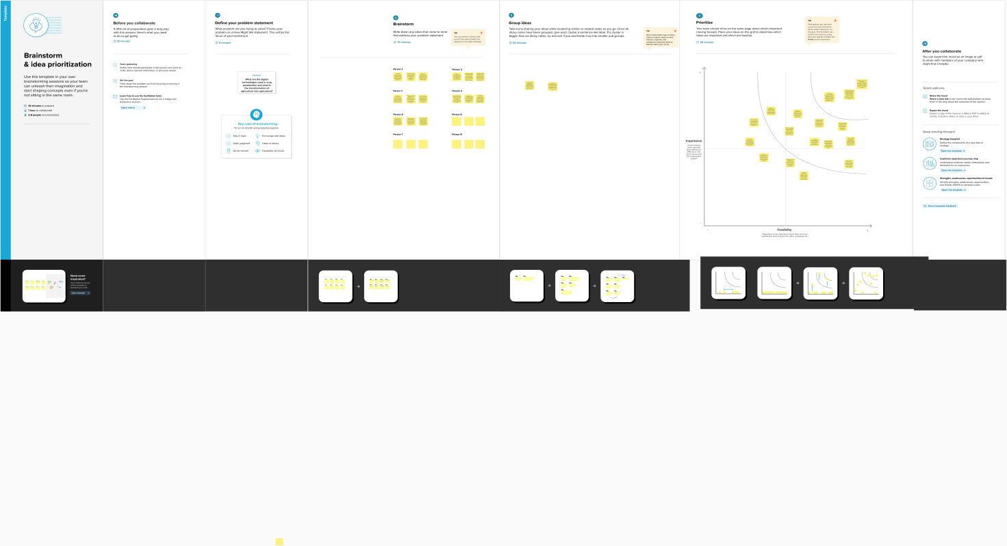

3. RESULT

Output of the project

The Screenshot of Dashboard and Story of our project are given below:

Dashboard:

Dashboard 1

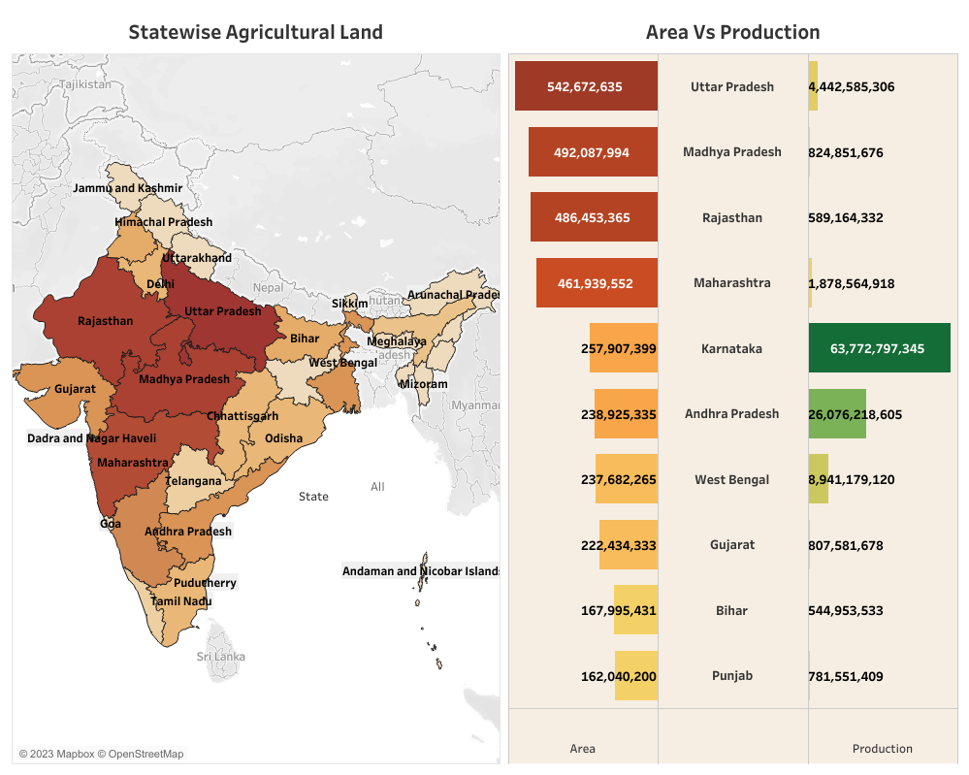

Dashboard 2

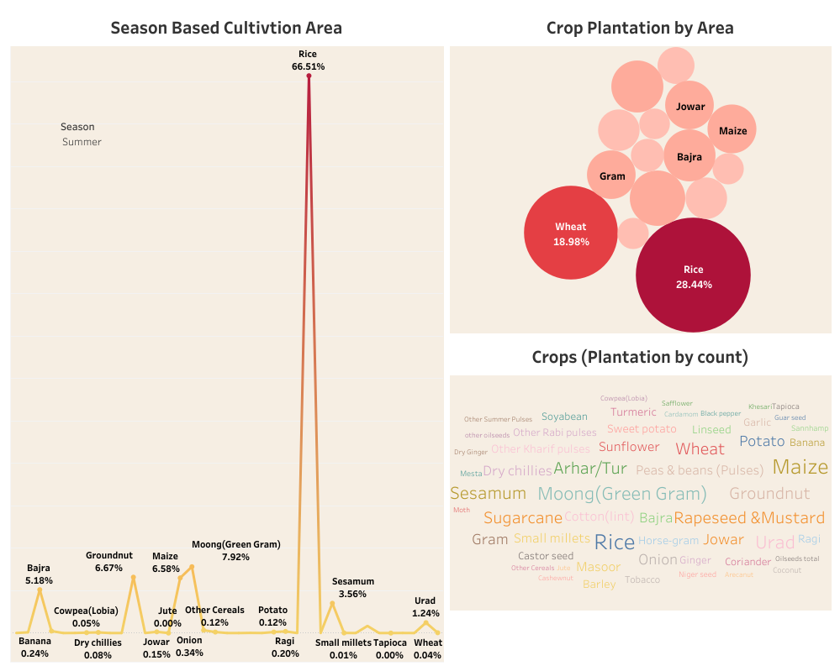

Dashboard 3

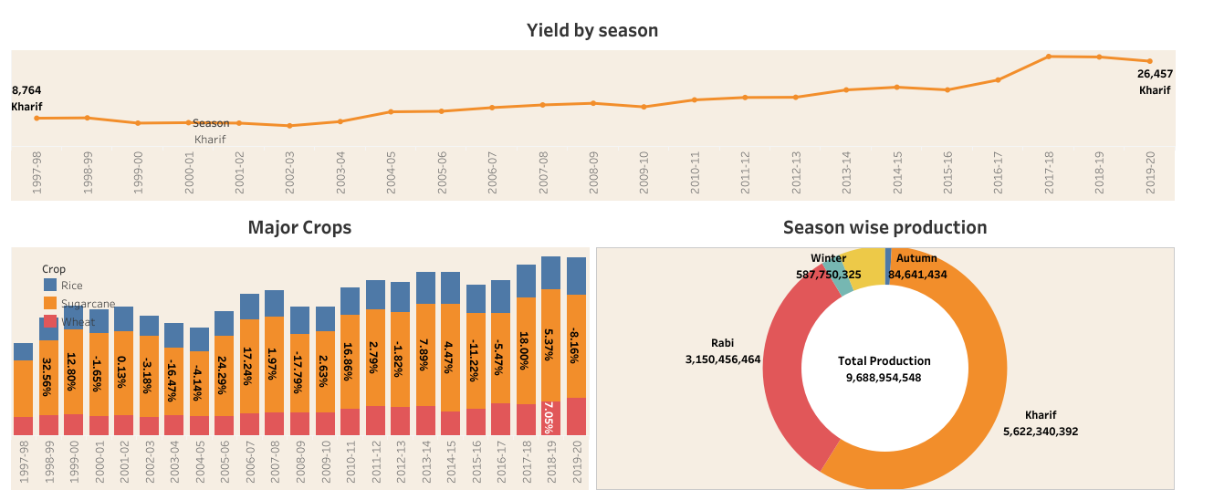

Story

Story 1

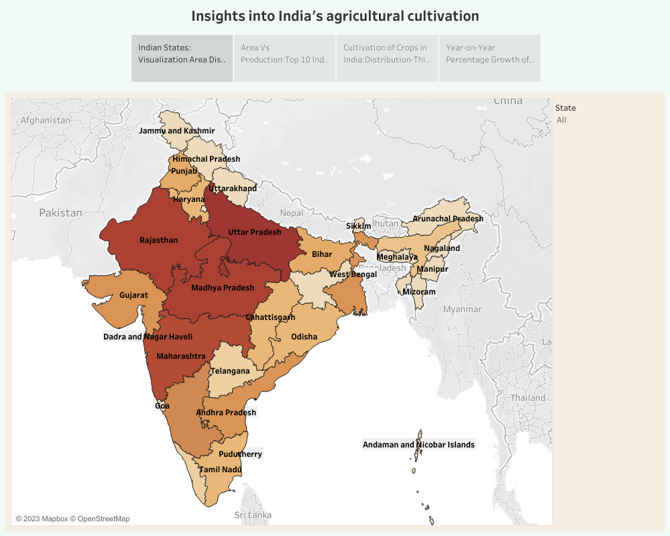

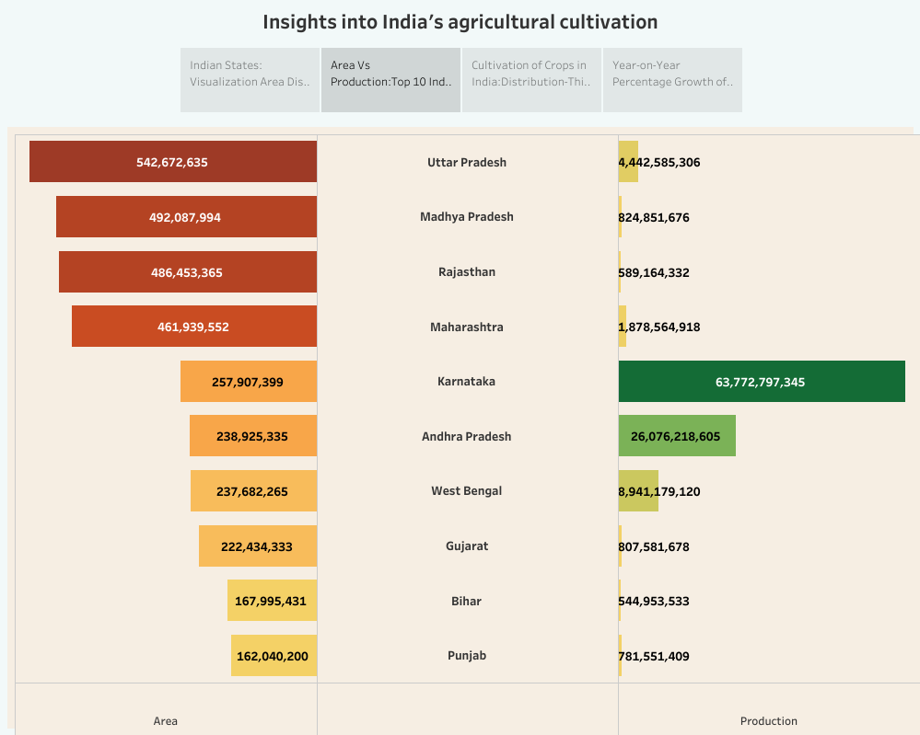

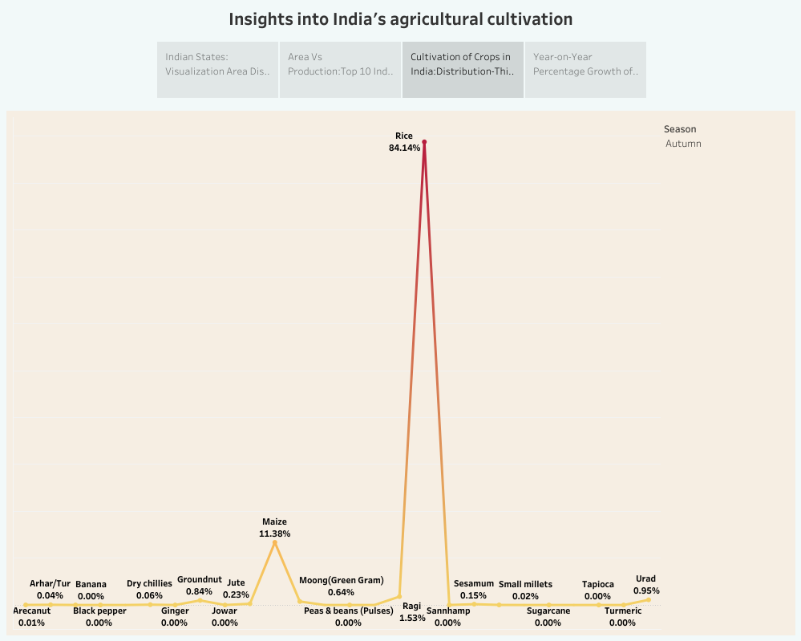

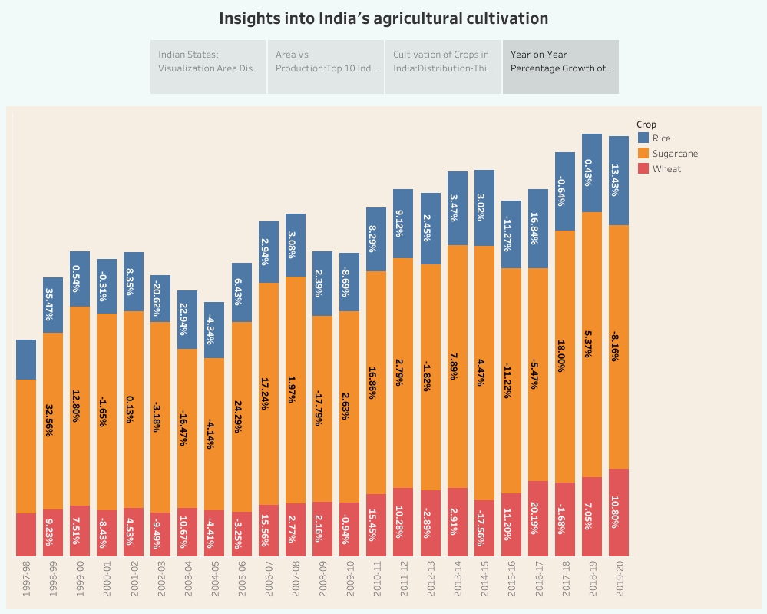

Story 2

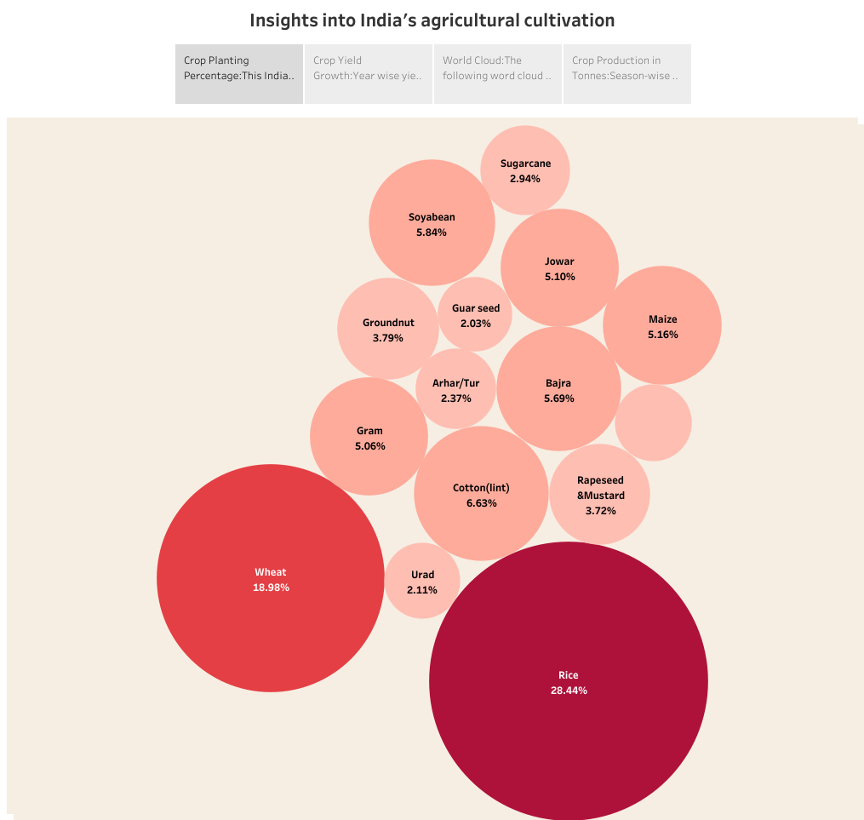

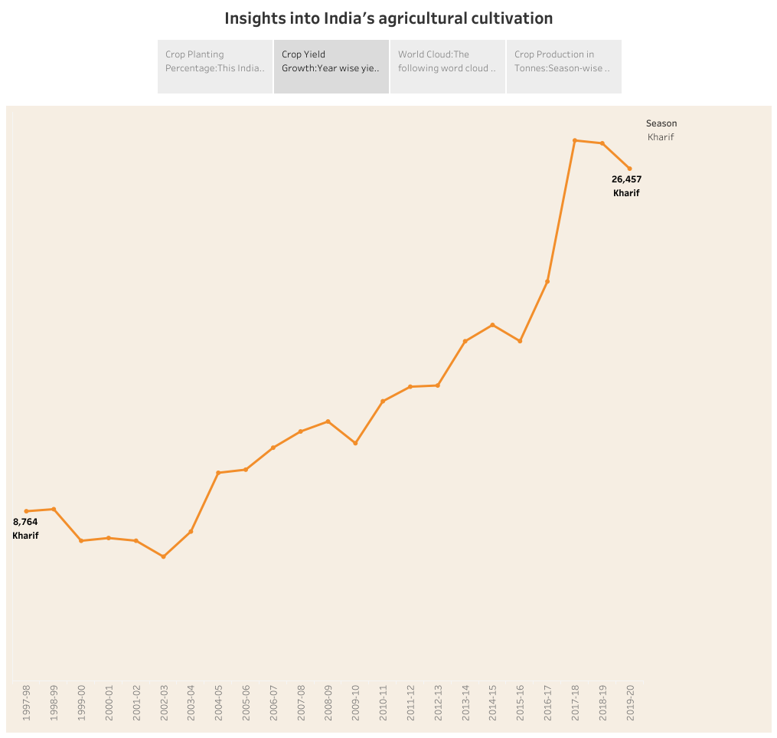

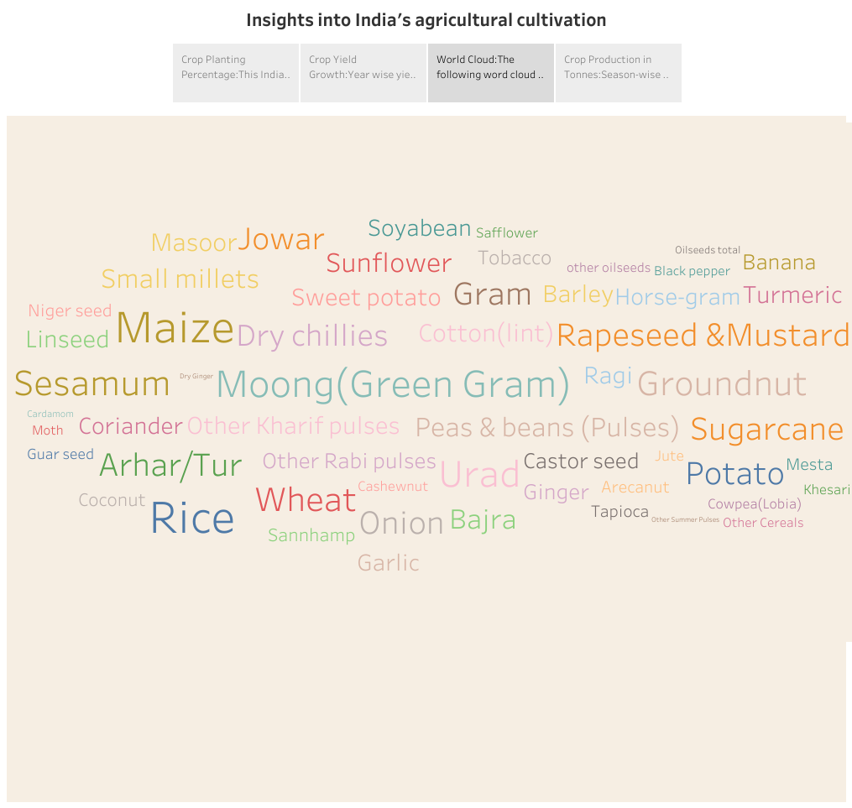

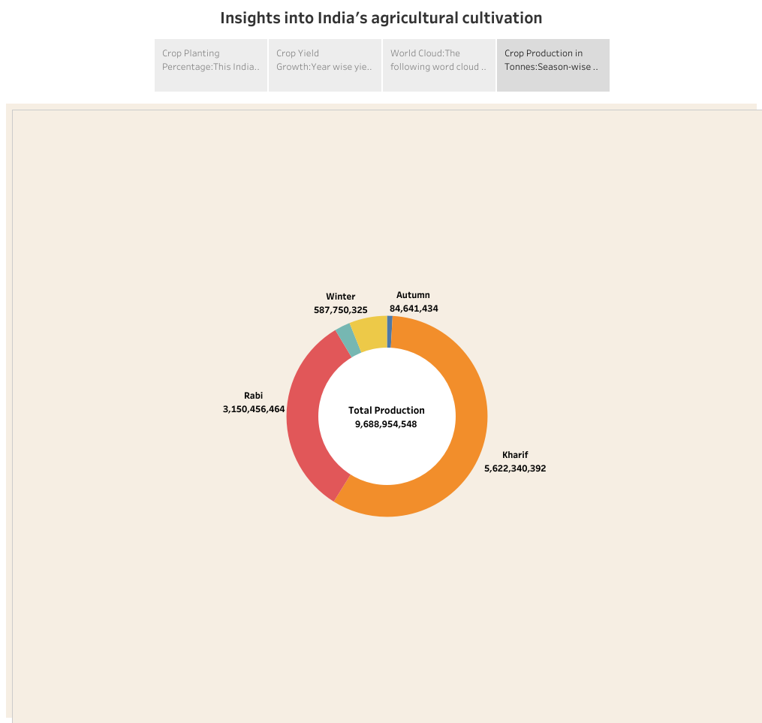

4. ADVANTAGES AND DISADVANTAGES

Advantages:

* Agriculture provides employment opportunity to the rural agricultural as well as non-agricultural laborers. It is the source of food and fodder.
* While residing in urban areas may be we would not realize is not new that agriculture is the main source of income for major part of our country’s population.

Disadvantages:

* Erosion of soil by heavy rain, floods, insufficient vegetation cover etc., reduces farm productivity.
* While the strength lies in having the largest cultivable land with record food grains production, our weakness lies in having low yields, less value addition and food processing and large amount of post harvest losses.

5. APPLICATION:

* Agriculture analysis is a very important very important aspect to crop growing.
* To increase quality and yields, it is crucial to understand the current nutrient levels of the soil to be able to ascertain which areas require improvement.
* Crop simulation models use quantitative descriptions of ecophysiological process to predict plant growth and development as influenced by environmental conditions and crop management.

6. CONCLUSION

In this topic, we learn about India’s agricultural crop production. Agricultural production is prone to several risks which affect both producers and consumers. In order to enhance investment and achieve a sustained increase in production, coherent and integrated long-term strategies and policies are required to reduce risk aversion and build flexibility among rural producers.

7. FUTURE SCOPE:

Due to globalization, increase in household incomes and health consciousness the demand for fruits and vegetables, dairy products, fish and meat is going to increase in future.

THANK YOU